2024—2025学年度第二学期期末质量监测
七年级英语试卷
一、听力测试（15分）
现在是试听时间。请听一段对话，然后回答问题。
M: I’m going shopping Mum. Do you need anything?
W: Yes, get some apples and some oranges to make juice with.
M: Well, we already have lots of oranges.
W: OK, just some apples then.
答案是C。
A）请听下面5段对话。每段对话后有一小题，从题中所给的A、B、C三个选项中选出最佳选项，并在答题卡上将该项涂黑。听完每段对话后，你都将有10秒钟的时间回答有关小题和阅读下一小题。每段对话读两遍。（每小题1分）
1. Whose football is this? 【此处可播放相关音频，请去附件查看】

A. Emma’s. B. Li Ming’s. C. Peter’s.
2. How is the weather now? 【此处可播放相关音频，请去附件查看】

A. Sunny. B. Snowy. C. Windy.
3. Why does Jack like monkeys? 【此处可播放相关音频，请去附件查看】

A. Because they’re so cute. B. Because they’re so lovely. C. Because they’re so clever.
4. What did Kate do yesterday afternoon? 【此处可播放相关音频，请去附件查看】

A. She went shopping. B. She studied English. C. She went on a school trip.
5. What does the girl mean? 【此处可播放相关音频，请去附件查看】

A. She doesn’t like tennis. B. She played tennis yesterday. C. She didn’t play tennis yesterday.
B）请听下面2段材料。每段材料后有几个小题，从题中所给的A、B、C三个选项中选出最佳选项，并在答题卡上将该项涂黑。听每段材料前，你将有时间阅读各个小题，每小题5秒钟；听完后，各小题给出5秒钟的作答时间。每段材料读两遍。（每小题1分）
请听1段材料，回答下面两个小题。【此处可播放相关音频，请去附件查看】

6. What is Teng Fei doing at the moment?
A. He is reading. B. He is exercising. C. He is making a call.
7. When do they meet at the park?
A. At 3:30 p.m. B. At 4:00 p.m. C. At 4:30 p.m.
请听1段材料，回答下面三个小题。【此处可播放相关音频，请去附件查看】

8. What kind of noodles would the man like?
A. Beef noodles. B. Mutton noodles. C. Pork noodles.
9. How much is the orange juice?
A. 2 yuan. B. 10 yuan. C. 12 yuan.
10. What can we get from the conversation?
A. The man spends 10 yuan in total.
B. The man doesn’t like beef noodles.
C. There are different kinds of noodles in the restaurant.
C）听独白完成句子。将答案填写到答题卡的相应位置。听独白前你将有50秒钟的时间阅读句子内容。独白读两遍。（每小题1分）
请听下面一段独白，根据独白内容完成下列句子，每个空格不超过3个单词。【此处可播放相关音频，请去附件查看】

11. Peter can’t play outside or ________ late.
12. Peter must ________ first after school.
13. Peter can’t use his phone during ________.
14. Peter’s mother says he must keep his room ________.
15. The rules are kind of ________ but helpful.
二、单项填空（8分）
请阅读下面各小题，从题中所给的A、B、C、D四个选项中选出可以填入空白处的最佳选项，并在答题卡上将该项涂黑。（每小题1分）
16. 找出画线部分读音不同于其他三项的选项。
A. head B. treat C. team D. eagle
17. —Lin Hui, is this pet dog yours?
—No, ________ has brown fur.
A. yours B. his C. hers D. mine
18. Alice ________ exercises, so she is in poor health now.
A. often B. always C. hardly D. usually
19. It’s ________ to greet our teachers when we meet them.
A. silly B. boring C. relaxing D. polite
20. —Tom, come and wash the car with me.
—Oh dad, he ________ in the kitchen.
A. cooks B. cooked C. will cook D. is cooking
21. Last week, the students visited a wastewater factory. It was an amazing ________ for them.
A. advice B. experience C. practice D. result
22. Every time Zhou Chen leaves his hometown, his parents ________ a bag with handmade food. He knows it’s all about his family’s love.
A. share B. make C. fill D. lose
23. —How was your Dragon Boat Festival?
—It was wonderful. I ________ the Dragon Boat Races with my parents.
A. watch B. watched C. will watch D. am watching
三、完形填空（22分）
A）请先阅读下面短文，掌握其大意，然后从各小题所给的A、B、C、D四个选项中选出可以填入相应空白处的最佳选项，并在答题卡上将该项涂黑。（每小题1分）
On March 20, something amazing happened at Hangzhou Jiulian Primary School. It was really a day to ____24____.
On that day, some students ____25____ squirrels (松鼠) jumping around two pine trees (松树). One tree was ____26____ the school, and the other was outside, a wall separated (使分离) them. ____27____, they had an idea, “The squirrels could move between the trees freely ____28____ we build a bridge (桥)!”
The students turned to their art teacher for ____29____ at once. The teacher quickly drew a picture of the bridge. In the afternoon, the students’ idea became ____30____. The school built a bridge with the teacher’s ____31____. The bridge joined the two pine trees together.
When the students saw the bridge, they were so ____32____. The squirrels could now run across the bridge to meet their friends. This bridge was more than just a(n) ____33____ for squirrels. It also ____34____ the students to turn good ideas into better things.
This day was truly ____35____ for the students. It would always stay in their hearts.
24. A. forget B. remember C. waste D. follow
25. A. felt B. heard C. smelled D. noticed
26. A. inside B. outside C. across D. between
27. A. Exactly B. Slowly C. Suddenly D. Certainly
28. A. if B. so C. but D. and
29. A. help B. praise C. message D. truth
30. A. perfect B. popular C. real D. colorful
31. A. notice B. goal C. energy D. picture
32. A. quiet B. excited C. unhappy D. sleepy
33. A. river B. road C. area D. forest
34. A. chose B. caused C. ordered D. encouraged
35. A. dangerous B. special C. terrible D. common
B）（每小题1分）
请先阅读下面短文，掌握其大意，然后用方框中所给单词的适当形式填空，并将答案填写到答题卡的相应位置。每个词限用一次。
live, also, they, awful, care, enough, kill, weight, hearing, although
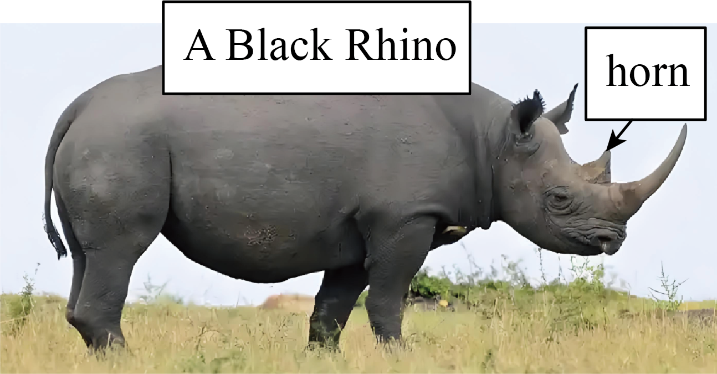
Black rhinos are large animals. They are about 1.5 meters tall with a ____36____ of 800 to 1,400 kilograms. ____37____ they look strong, they eat only plants.
Rhinos have ____38____ eyesight. They sometimes walk into trees or rocks. But they have good ____39____. When in danger, they use ____40____ big horns as weapons (武器). Mother rhinos ____41____ use them to keep away from lions.
Mother black rhinos are wonderful moms. They take good ____42____ of their babies for a long time. They teach them how ____43____ alone. Baby rhinos stay with their moms until they are big ____44____ to live on their own.
However, rhinos are in great danger. Many people ____45____ them for their horns. Let’s save them and not buy things made of horns.
四、阅读理解（40分）
A）请阅读下面短文，根据短文内容从每小题所给的A、B、C、D四个选项中选出最佳选项，并在答题卡上将该项涂黑。（每小题2分）
A
Today is Mother’s Day. Children from different countries are celebrating it in different ways! They hope that their mothers will get lots of love, smiles, and hugs on this special day.
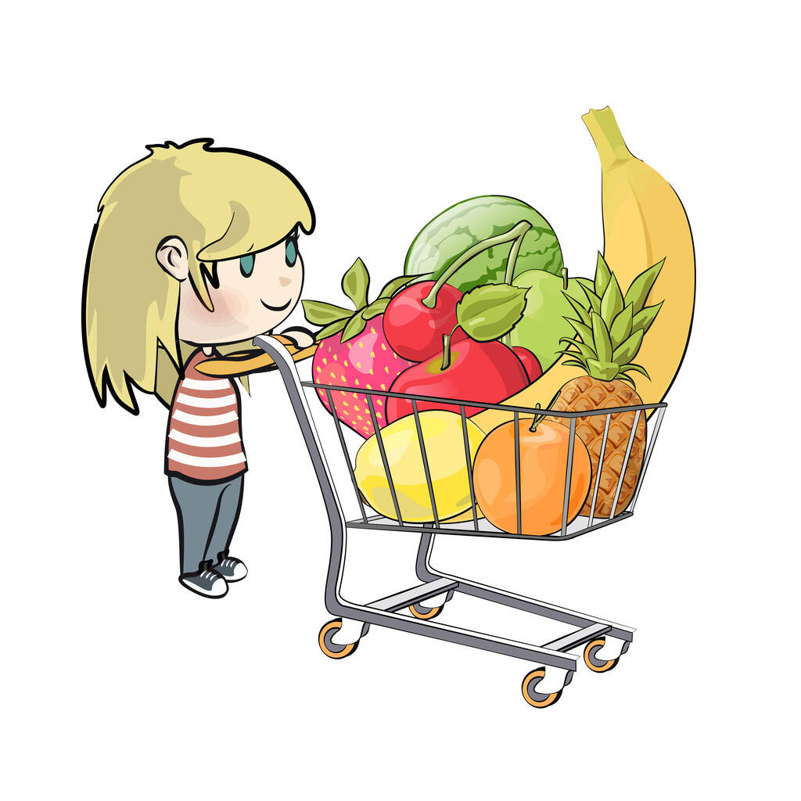 | I’m buying fruit at the supermarket. I plan to make a fruit salad as a surprise. Where is my dad? What is he doing? He is helping us cook a special lunch for Mother’s Day.  Helen 9:15 a.m. 11 May 
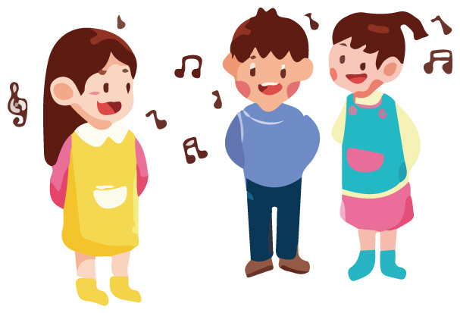 | I’m singing a traditional (传统的) song with my classmates. We are practicing for Mother’s Day. My brother, Kiprono, is helping our grandmother weave (编织) a small basket. They will put fresh bananas in it as a gift.  Wanjiku 11:00 a.m. 11 May
 | I’m drawing a beautiful flower on a card. My sister, Zhang Li, is cutting a heart-shaped card out of red paper. We are both working hard to show our love to mom.  Zhang Hua 4:00 p.m. 11 May

46. The passage is probably a ________.
A. story B. post C. diary D. letter
47. What is Wanjiku doing for her mom?
A. Making a fruit salad. B. Putting fresh bananas.
C. Singing a traditional song. D. Drawing a heart-shaped card.
48. What would you say to Zhang Hua if you are his friend?
A. This gift is too cheap. B. Happy birthday to your mother.
C. I don’t think your mom will love it. D. A nice gift, your mom will be happy.
B
Do you eat potatoes often? Get ready to learn more about them.
Potatoes are becoming China’s fourth staple food (主食), after rice, wheat (小麦), and corn. Eating potatoes as a staple food can make our meals healthier and more balanced.
Potatoes are healthy. First, they are rich in Vitamin C and B6. In fact, one potato has as much Vitamin C as 10 apples! Second, potatoes have fewer calories (卡路里) than wheat or corn. This means they don’t make you put on weight easily.
Potatoes are also great for farmers. Potatoes don’t need much water and are easy to grow. People can grow them in most parts of China. China is facing water shortage problem, so potatoes are a good choice. Potatoes grow fast too. This makes them cheap and easy to buy in stores.
In short, potatoes are very useful and healthy. You can boil them, bake (烤) them, or fry them. No matter how you cook them, they always taste good.
49. What does the underlined word “they” in Paragraph 3 refer to?
A. 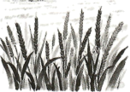 B. 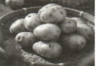 C. 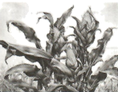 D. 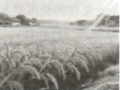
50. What does the underlined word “shortage” in Paragraph 4 mean?
A. 短缺 B. 贫困 C. 短暂 D. 富饶
51. Which of the following is TRUE?
A. Potatoes are expensive to buy. B. Potatoes need a lot of water to grow.
C. Potatoes are China’s third staple food. D. One potato has as much Vitamin C as 10 apples.
52. What would be the best title for the passage?
A. Ways to Cook Potatoes B. The History of Potatoes in China
C. The Reasons Why Potatoes Are Not Popular D. Potatoes: A Healthy and Useful Staple Food
C
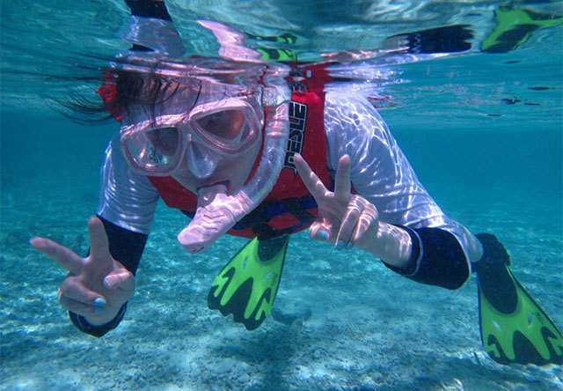
Hi, I’m Mia. Snorkeling is one of my favorite outdoor sports.
On sunny weekends, I take a bus to a beach on the other side of the island with friends. We put on snorkels, fins (脚蹼), and masks (面罩). Then our teacher tells us the safety rules before we jump into the clear blue water.
The sunlight shines through the water and we swim around looking at the fish. Some are very brightly colored, some have special markings like lines and dots (点). The coral (珊瑚) is beautiful too. Lots of little fish swim among it. I’m excited to see this magical underwater world. Every time I snorkel, I feel like a hunter searching for new and exciting things underwater.
I love snorkeling. On the one hand, it is my way to explore nature. On the other hand, this fun sport makes my body stronger, especially my heart and lungs (肺部).
53. Put the following statements in the right order.
a．Our teacher tells us safety rules. b．We jump into the clear blue water.
c．We put on snorkels, fins, and masks. d．I see colorful fish and coral in the clear blue water.
A. a→c→b→d B. b→a→d→c C. c→a→b→d D. c→b→d→a
54. What is the main idea of Paragraph 3?
A. To tell us how to snorkel. B. To tell us to find a favourite sport.
C. To tell the reasons why Mia likes snorkeling. D. To tell us what Mia saw and felt when snorkeling.
55. According to the passage, why does Mia love snorkeling?
①She can be stronger. ②She can wear cool masks.
③She can explore the nature. ④She likes beach sports.
A. ①② B. ③④ C. ①③ D. ②④
56. What would be the best structure for the passage?
A. ①/②③/④ B. ①②③/④ C. ①②/③④ D. ①/②/③④
D
The twelve Chinese zodiac animals (生肖) met together to celebrate the coming new year. Everyone was happy, but only Snake felt down. “People don’t like me,” Snake thought, “I’m not as strong as Tiger, nor as friendly as Dog. I’m not as helpful as Cow and Horse. And I’m not as lovely and sunny as the other animals. I am nothing. Maybe I shouldn’t be here.”
Snake was so sad that he left his friends and walked along the river. Suddenly, he noticed something unusual. The ground began to shake (摇晃). He heard a huge noise coming from the upper part of the river. ________ Snake said, “The water will destroy (破坏) the farming land.”
Snake ran quickly to the village. The farmers in the village noticed the rising water, too. When they saw Snake, they shouted, “Look, a snake! Snakes are good at finding safe places. Follow him!” Snake felt happy. He guided (指引) the people to the higher ground and found a new piece of farmland.
The people were thankful for his help and wanted to give him some delicious food But Snake walked away. He has already got what he needed. He realized that each animal has something special it can do. He felt proud (骄傲) that he was one of the Twelve and waited for his turn to be the symbol of the year.
57. Choose the best sentence to fill in the blank “________” in Paragraph 2.
A. “Oh, I must help!” B. “Oh, I need help!”
C. “Oh, I must run away!” D. “Oh, I need to find a farmland.”
58. Why did the villagers follow Snake?
A. To give the snake some food. B. To get to a safe place quickly.
C. To find a new piece of farmland. D. To wait for the coming year in a new place.
59. How did Snake’s feelings change?
A. angry→sad→excited B. happy→sad→excited
C. sad→proud→happy D. sad→happy→proud
60. What can we learn from the story?
A. Every animal has its special ability. B. People only like strong and lovely animals.
C. Snakes are the smartest animals of the Twelve. D. People only like animals that can do big things.
B）请先阅读下面短文，掌握其大意，然后根据短文内容从下面方框内的七个选项中选择五个还原到文中，使短文意思通顺、结构完整，并在答题卡上将其序号涂黑。一空一句。（每小题2分）
Let’s Learn About Time Zones
Can you imagine (想象) what the world would be like if everywhere had the same time? It would be really strange! ____61____
What are times zones?
Time zones are like big pieces that divide (划分) the Earth into different parts. ____62____ This helps people know when to get up, eat lunch, or go to bed.
Why do we need time zones?
The Earth is just like a big ball. It spins (旋转) all the way around once every 24 hours. ____63____ When it’s daytime in China, but on the other side of the world, like in America, it’s nighttime and dark outside.
____64____
You can look at a special map to see which time zone you’re in. For example, everyone in China uses CST (中国标准时间). In London, they use a time called UTC. ____65____ This shows that Beijing Time is 8 hours ahead of (早于) London Time.
So, next time you check the clock, remember: different time, one world!
A. This is a very good question.
B. Why are time zones important?
C How can we find our time zones?
D. Each part follows its own clock time.
E. Let’s learn about time zones in an easy way.
F. Only one side of the Earth faces the sun at a time.
G. When it’s 12:00 noon in London, it’s 20:00 in Beijing.
五、补全对话（5分）
请阅读下面对话，根据对话内容从下面的七个选项中选择五个填入空白处，使对话通顺、合理，意思完整，并在答题卡上将其序号涂黑。一空一句。
(Helen and Jane are talking on the phone. A= Jane; B= Helen.)
A: Hello. May I speak to Helen?
B: Hi, it’s Helen. ____66____
A: This is Jane. How’s everything going in your new school?
B: ____67____ All my classmates are friendly to me.
A: Do you have any rules in your school?
B: Of course. ____68____
A: What are some of the rules?
B: ____69____ I can’t arrive late for class, either.
A: Are there any others rules?
B: Yes I have to wear the school uniform. ____70____
A: Me, too. It helps to build school spirit. Oh, I have to go now. Let’s talk later.
B: OK. Bye!
A. Pretty good.
B. Who’s that?
C. Are you Jane?
D. What about you?
E. No rules, no order.
F. I can’t use my phone in class.
G. I have to do some cleaning on weekends.
六、书面表达（10分）
71. 假如你是李明，Peter是你的美国笔友。最近他给你发了一封电子邮件，询问相关信息。请根据邮件内容，用英语给他回一封邮件。
Dear Li Ming,
How are you these days? I want to know something about your May Day. Did you do anything interesting on May 1st? What was it? What did you do or see? How did you feel? What did you learn? Please write to me.
Yours,
Peter
要求：
1. 根据邮件内容进行回复，可适当拓展。
2. 60词左右，开头和结尾已给出，不计入总词数。
Dear Peter,
Thanks for your e-mail. I’m very happy to tell you something about my holiday.
______________________________________________________________________________________________________________________________________________________________________________________________________________________________________________________________________________________________________________________________________________________________________________________________________________________________________________________________________________________________________________________________________________________________________________________________________________________________________________________________
Yours,
Li Ming

