2024学年第二学期九年级调研测试
英语（问卷）
（时间：100分钟 总分：90分）
注意事项：
1. 答卷前，考生务必在答题卡上用黑色字迹的钢笔或签字笔填写镇（街）、学校、试室号、姓名、座位号及准考证号，并用2B铅笔填涂准考证号。
2. 选择题每小题选出答案后，用2B 铅笔把答题卡上对应题目的答案标号涂黑。如需要改动，用橡皮擦干净后，再选涂其他答案；不能答在试卷上。
3. 非选择题必须用黑色字迹的钢笔或签字笔作答，答案必须写在答题卡各题目指定区域的相应位置上；如需要改动，先划掉原来的答案，然后再写上新的答案，改动的答案也不能超出指定的区域；不准使用铅笔、圆珠笔和涂改液。不按以上要求作答的答案无效。
4. 考生必须保持答题卡的整洁，考试结束将问卷和答题卡一并交回。
一、语法选择（共15小题；每小题1分，满分15分）
阅读下面短文，按照句子结构的语法性和上下文连贯的要求，从所给的A、B、C和D项中选出最佳选项，并在答题卡上将该项涂黑。
David was walking home from school. He saw a small dog. The dog ___1___ cold and shivering (颤抖). David picked it up ___2___ and took it home. His mother was surprised ___3___ the dog.
“Can we keep it, Mom? ” David asked.
His mother thought for a moment. “Well, we need to check ___4___ it has an owner, ” she said. Over the next few days, David put up posters around the neighborhood. He hoped that the dog’s owner would see the posters and call them. He waited for four weeks, ___5___ nobody called.
“It seems that the dog has no owner, ” his mother said, “I think we should give this little one a new home. ” David was so happy that he couldn’t stop ___6___. He decided to give the dog a name. At last, the dog ___7___ Bobbie.
One afternoon, Bobbie suddenly barked ___8___ the door when David was doing his homework. David saw ___9___ woman standing outside. “Excuse me, I saw your poster and recognized the dog in the picture. That’s my dog! He went missing last month. ”
Bobbie was wagging his tail happily and jumped around the woman. That meant he recognized his owner ___10___.
“Yes, he’s here, ” David said. ___11___ he didn’t want to say goodbye, he knew that Bobbie should go home with his owner.
“Thank you so much! I’ve been looking for him everywhere, ” the woman said.
David whispered to Bobbie, “I’ll miss ___12___. ”
“You know, I travel a lot for work and have ___13___ time to take care of him. He seems so happy here with you, ___14___ you like to be his new owner and allow me to visit him whenever I can? ”
“Yes! I’d love to! Actually, Bobbie has become one of my ___15___ friends, ” David said excitedly. And from that day on, they lived happily together.
1. A. is B. are C. was D. were
2. A. gentle B. gently C. gentleness D. gentling
3. A. see B. seeing C. to see D. seen
4. A. when B. if C. unless D. until
5. A. and B. so C. or D. but
6. A. smiling B. smile C. to smile D. smiled
7. A. name B. named C. was named D. was naming
8. A. in B. at C. on D. under
9. A. a B. an C. the D. /
10. A. either B. also C. neither D. too
11. A. So B. Because C. As D. Although
12. A. you B. your C. yours D. yourself
13. A. few B. a few C. little D. a little
14. A. Must B. Need C. Might D. Would
15. A. good B. better C. best D. the best
【答案】1. C 2. B 3. C 4. B 5. D 6. A 7. C 8. B 9. A 10. D 11. D 12. A 13. C 14. D 15. C
【解析】
【导语】本文讲述了David偶遇流浪狗并善意收养，最终与狗主人达成共识温暖故事。
【1题详解】
句意：他看到一只小狗，它当时又冷又颤抖。
is一般现在时，主语是单数；are一般现在时，主语是复数；was一般过去时，主语是单数；were一般过去时，主语是复数。根据故事背景“was walking”可知是过去时，主语the dog为单数，be动词用was，故选C。
【2题详解】
句意：David轻柔地把它捡起来带回了家。
gentle温柔的，形容词；gently温柔地，副词；gentleness温柔，名词；gentling错误表达。此处修饰动词picked up，用副词gently。故选B。
【3题详解】
句意：他妈妈看到狗后感到惊讶。
see看，原形；seeing正在看，动名词；to see看，不定式；seen看，过去分词。surprised后面应接不定式表示“看到……感到惊讶”，故选C。
4题详解】
句意：我们需要确认它是否有主人。
when什么时候；if是否；unless除非；until直到。这条狗是捡的，不知道有没有主人。此处为宾语从句，确认“是否有主人”用if引导。故选B。
【5题详解】
句意：他等了四个星期，但没人打电话。
and和；so所以；or或者；but但是。根据“He waited for four weeks,...nobody called.”可知前后句为转折关系，应用but，故选D。
【6题详解】
句意：David高兴得忍不住笑了。
smiling正在笑，动名词；smile笑，动词原形；to smile笑，不定式；smiled笑，过去式。“couldn’t stop doing sth.”表示“忍不住做某事”，固定搭配，用smiling。故选A。
【7题详解】
句意：最终这只狗被命名为Bobbie。
name动词原形；named过去式；was named被动语态；was naming进行式。此处表示“被命名”，用被动语态be done，故选C。
【8题详解】
句意：一天下午，当David正在做他的家庭作业时，狗突然在门口叫起来。
in在里面；at在……处；on在……上；under在下面。bark at表示“朝……叫”，固定搭配。故选B。
【9题详解】
句意：David看到一位女士站在外面。
a一，用于辅音音素开头；an一，用于元音音素开头；the特指；/无冠词。这里泛指一个女人，woman以辅音音素开头，应用a。故选A。
【10题详解】
句意：这意味着它也认出了主人。
either也，用于否定；also也，用于肯定句句中；neither都不；too也，用于肯定句句末。根据“Bobbie was wagging his tail happily and jumped around the woman.”可知，狗也认出了主人，且这个空在句末，故选D。
【11题详解】
句意：尽管他不想说再见，他还是知道狗应该和它的主人回家。
So所以；Because因为；As因为；Although虽然。根据“...he didn’t want to say goodbye, he knew that Bobbie should go home with his owner.”可知是让步关系，应用although引导，故选D。
【12题详解】
句意：David轻声对Bobbie说：“我会想你的。”
you你，宾格；your你的，形容词性物主代词；yours你的，名词性物主代词；yourself你自己。动词miss后面跟代词的宾格，故选A。
【13题详解】
句意：你知道，我工作出差多，几乎没时间照顾它。
few很少，修饰可数名词复数；a few几个；little几乎没有，修饰不可数名词；a little一点。time为不可数名词，用little表示“几乎没有时间”。故选C。
【14题详解】
句意：他和你在一起看起来很开心，你愿意做它的新主人吗？
Must必须；Need需要；Might也许；Would愿意。“Would you like…?”为常用委婉请求句式。故选D。
【15题详解】
句意：“是的！我愿意！Bobbie已经成了我最好的朋友之一。”David兴奋地说。
good好；better更好；best最好；the best最好的。one of +the+形容词最高级+复数名词，表示“最……之一”，是固定表达。故选C。
二、完形填空（共10小题：每小题1分，满分10分）
阅读下面短文，掌握其大意，然后从16~25 各题所给的A、B、C和D项中选出最佳选项。
In a quiet forest, animals were worried because their drinking river dried up. Deer dug holes, rabbits ___16___ for water, but nothing worked. Oliver was a young owl (猫头鹰). He sat on a tree and watched with his large round eyes. “Maybe we should ___17___ something different,” Oliver thought. He noticed ants carrying water drops toward the same direction every day. “Why are they going that way?” he wondered. He followed the ants with ___18___ and saw a stone. Under the stone lay a covered water hole. He moved the stone away with his ___19___ claws (爪子). Soon, fresh water came out. The animals cheered ___20___, jumping and dancing around the water hole. But the fox laughed loudly, “You were just ___21___! This is nothing special!” Oliver replied, “Solutions come from thinking and ___22___ what others do. ”
One day, a big storm came. Other animals were ___23___ and they didn’t know what to do. Oliver led them to a hidden place under a large old tree. “How did you know this place?” asked a rabbit. “I flew around and eventually found this place last night.” Oliver answered. The storm swept through the forest, but they stayed safe. After the storm, the animals rebuilt their ___24___. They realized Oliver’s observation ability and kindness had saved them.
Now they often sit under Oliver’s tree and learn to ___25___ nature’s messages. The forest is full of life again.
16. A. cared B. looked C. came D. paid
17. A. avoid B. describe C. try D. forget
18. A. interest B. sadness C. pride D. anger
19. A. fat B. strong C. broken D. tiny
20. A. excitedly B. angrily C. nervously D. softly
21. A. lucky B. crazy C. brave D. tired
22. A. watching B. challenging C. testing D. asking
23. A. happy B. scared C. lonely D. hopeful
24. A. parks B. bridges C. roads D. homes
25 A. paint B. send C. read D. write
【答案】16. B 17. C 18. A 19. B 20. A 21. B 22. A 23. B 24. D 25. C
【解析】
【导语】本文主要讲述了在森林里，动物们因为它们的饮用水干涸而感到担忧。猫头鹰奥利弗通过观察蚂蚁发现了一个有水的地方，解决了动物们的饮水问题。并且在大风暴来临时，动物们躲进了奥利弗发现的地方，躲过了风暴。
【16题详解】
句意：鹿挖洞，兔子找水，但什么也没用。
cared关心；looked看；came来；paid支付。根据前一句“ In a quiet forest, animals were worried because their drinking river dried up. ”和选项可知，这里表示寻找水。look for“寻找”。故选B。
【17题详解】
句意：“也许我们应该尝试一些不同的东西，”奥利弗想。
avoid避免；describe描述；try尝试；forget忘记。根据前文“Deer dug holes, rabbits ... for water, but nothing worked.”和选项可知，这里表示尝试一些不同的东西。故选C。
【18题详解】
句意：他饶有兴趣地跟着蚂蚁，看到了一块石头。
interest兴趣；sadness悲伤；pride骄傲；anger生气。根据前一句“‘Why are they going that way?’ he wondered.”和选项可知，这里饶有兴趣地跟着蚂蚁。with interest“饶有兴趣地”。故选A。
【19题详解】
句意：他用小爪子把石头移开了。
fat肥胖的；strong强壮的；broken坏的；tiny小的。根据空后的“claws”和选项可知，这里表示猫头鹰用自己的强壮的爪子把石头移开。故选B。
【20题详解】
句意：动物们兴奋地欢呼着，在水坑周围蹦蹦跳跳。
excitedly兴奋地；angrily生气地；nervously紧张地；softly温柔地。根据下文“ jumping and dancing around the water hole”和选项可知 这里表示动物们兴奋地欢呼着。故选A。
【21题详解】
句意：你简直疯了！
lucky幸运的；crazy疯狂的；brave勇敢的；tired累的。根据后一句“This is nothing special!”和选项可知，这里表示疯了。故选B。
【22题详解】
句意：解决方案来自思考和观察他人的行为。
watching观察；challenging挑战；testing测试；asking询问。根据空后的“what others do”和选项可知，这里表达观察他人的行为。故选A。
【23题详解】
句意：其他动物很害怕，不知道该怎么办。
happy高兴的；scared害怕的；lonely孤独的；hopeful充满希望的。根据前一句“One day, a big storm came.”和选项可知，这里表示动物们很害怕。故选B。
【24题详解】
句意：暴风雨过后，动物们重建了家园。
parks公园；bridges桥；roads路；homes家。根据“After the storm, the animals rebuilt their和选项可知，这里表示重建家园。故选D。
【25题详解】
句意：现在，他们经常坐在奥利弗的树下，学习阅读大自然的信息。
paint绘画；send发送；read阅读；写。根据空后的“ nature’s messages”和选项可知，这里表达。故选C。
三、阅读（共两节，满分35分）
第一节 阅读理解（共15小题；每小题2分，满分30分）
A
Amy was a quiet girl who loved reading but hated attention. She felt nervous when her English teacher, Mrs. Green, announced a school play. “Everyone needs to join,” Mrs. Green said with a smile.
Amy’s friend, Emma, spoke quietly, “You’d be perfect for a role! Think about it! It’ll be fun!”
“Fun? Not for me,” Amy replied softly. “I’d rather stay behind the scenes.”
But Mrs. Green encouraged her. “Amy, even if you don’t like speaking, you can still help. How about playing the Cheshire Cat in Alice in Wonderland? You only need to smile and disappear—no words to remember.”
Amy thought for a moment “Just smiling and disappearing?”
“Yes,” Mrs. Green said. “And maybe a little bit of playful fun.”
Amy nodded, though she wasn’t sure. During practice, she stood quietly in the corner, practicing her smile of mystery. One day, the lead actor, Tom, forgot his lines. The room went silent.
“I… I can’t remember,” said Tom, and his face turned red.
Without thinking, Amy stepped forward. She waved her arms and made funny faces as the Cheshire Cat. The class laughed, and Tom relaxed.
“Great job, Amy!” Emma cheered.
Mrs. Green smiled. “You’re better at this than you think, Amy. Don’t doubt yourself.”
On the day of the play, Tom faltered again. The audience started to talk quietly. Amy’s heart raced, but she remembered what she had done during practice. With a deep breath, she jumped into action, waving her arms and making silly faces. Her movements made the Cheshire Cat come to life. The crowd laughed, and Tom could pick up his lines and continued his part.
After the play, Mrs. Green talked to Amy. “You were wonderful,” she said. “You showed everyone that even without words, you can make a big difference. You taught us that silence isn’t emptiness— it’s a space for imagination.”
Amy smiled. For the first time, she felt proud of being quiet.
26. What does the beginning of the story tell us about Amy?
A. She didn’t like her classmates at all. B. She didn’t want to be noticed by others.
C. She had no time to remember the words. D. She wasn’t worried about the school play.
27. Why did Mrs. Green ask Amy to play the Cheshire Cat?
A. Because the role didn’t need to talk. B. Because she thought Amy liked cats.
C. Because the role needed acting skills. D. Because Amy wanted to try a new role.
28. How did Amy help Tom on the day of the play?
A. She asked the audience to wait patiently. B. She shouted to remind him of the words.
C. She acted as the lead actor instead of Tom. D. She used funny actions to relax the audience.
29. What lesson can you learn from this story?
A. Quiet people can succeed in their own way. B. Imagination is more powerful than words.
C. Teamwork requires everyone to speak up. D. Confidence can help solve every problem.
【答案】26. B 27. A 28. D 29. A
【解析】
【导语】本文讲述了一个性格安静、不爱引人注目的女孩Amy如何通过参与校园戏剧表演突破自我、发现自身价值的故事。
【26题详解】
细节理解题。根据“Amy was a quiet girl who loved reading but hated attention.”可知，她不喜欢被他人关注。故选B。
【27题详解】
细节理解题。根据“You only need to smile and disappear—no words to remember.”可知，这个角色不需要说话。故选A。
【28题详解】
细节理解题。根据“On the day of the play, Tom faltered again. The audience started to talk quietly…With a deep breath, she jumped into action, waving her arms and making silly faces.”可知，她用滑稽动作缓解了观众情绪。故选D。
【29题详解】
主旨大意题。本文讲述了一个性格安静、不爱引人注目的女孩Amy如何通过参与校园戏剧表演突破自我、发现自身价值的故事。因此安静的人也能以独特方式成功。故选A。
B
In 2019, I started learning Chinese at the Confucius Institute (孔子学院) in London. Though I spoke several foreign languages, Chinese felt totally new to me. Characters looked like difficult pictures, but their beauty attracted me into learning Chinese. Tones (声调) reminded me of singing, and sentences followed rules I’d never seen before. Every lesson brought both challenges and surprises.
Soon, I realized language was just the key to a greater treasure: China’s rich cultural world. My teachers introduced me to Tang poems’ short yet powerful lines, which painted lively scenes in just a few words. Ancient books like The Book of Songs showed how poetry expressed Chinese thoughts long ago. My interest grew into different areas. Philosophy (哲学) classes taught me about Confucius’ wisdom. Art history opened my eyes to ink paintings where mountains and rivers seemed to dance on paper.
One exciting discovery was about China’s powerful women. I met stories of FuHao, a brave army leader from ancient times, and Wu Zetian, the only female emperor. Their lives showed women shaped China’s history in special ways that textbooks sometimes forget.
These experiences lit a dream in me: to build a cultural bridge! Why not share these amazing stories through a magazine? I pictured pages filled with Chinese tradition—tea art, myths (神话), festivals, and those wonderful poems. The magazine would use simple English. Many people here in London find Chinese culture distant, but colorful photos and interesting articles could bring it closer.
Now, whenever I write, I imagine curious teenagers turning the magazine’s pages, eyes widening at China’s wonders. My journey began with simple “nihao” but became an adventure connecting two worlds. As long as people stay interested, this bridge between cultures will keep growing.
30. What made the writer study Chinese?
A. The chance to travel to China. B. The beauty of Chinese characters.
C. The grammar of Chinese sentences. D. The difference from other languages.
31. What did the writer think of language?
A. It’s a tool for exploring culture. B. It’s a key to getting great wealth.
C. It’s a method for communication. D. It’s a way to study ancient views.
32. Which would be the best front page for the writer’s magazine?
A. 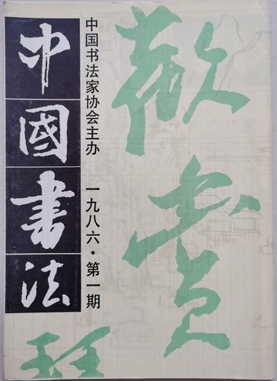 B. 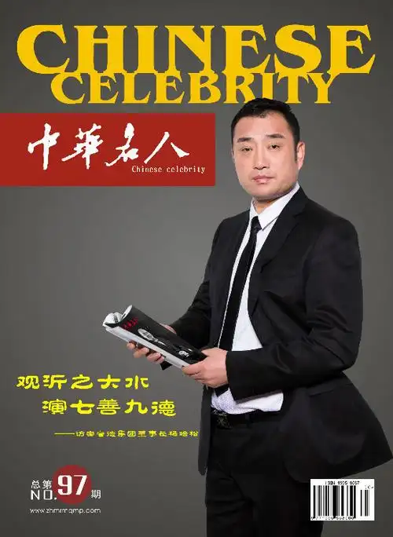 C. 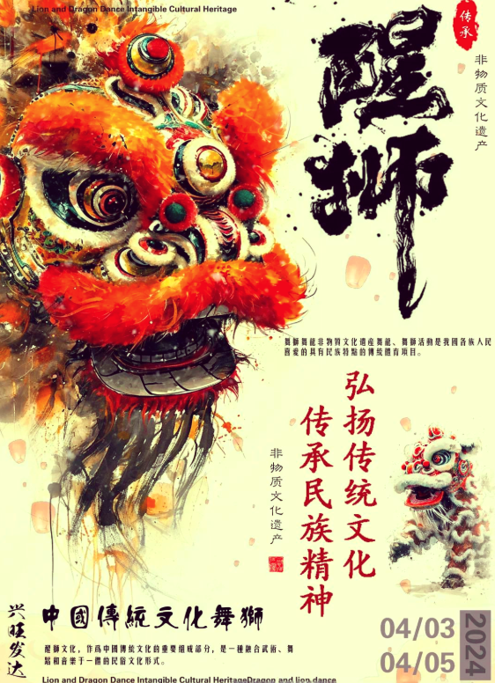 D. 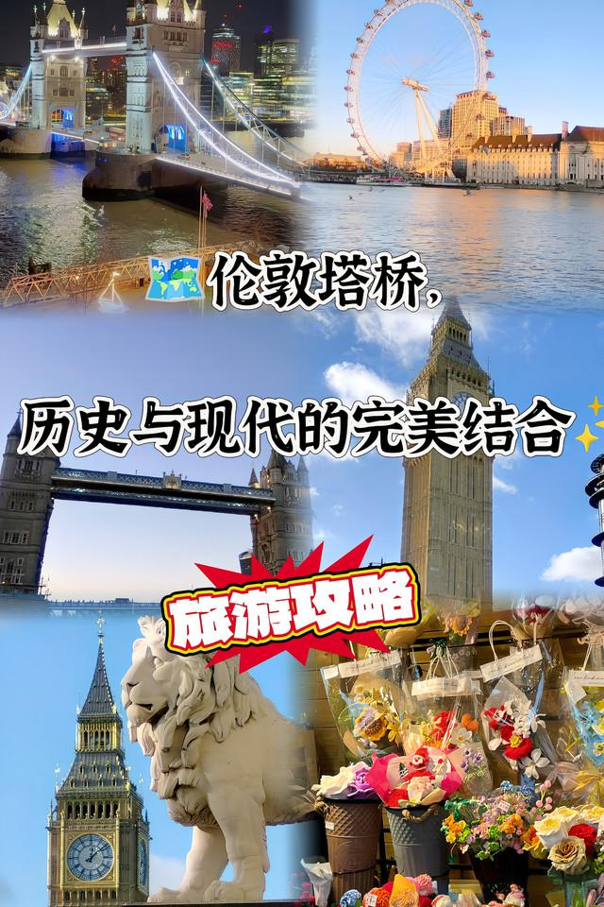
33. How did the writer feel about learning Chinese?
A. It was challenging and tiring. B. It focused on ancient history.
C. It created cultural connections. D. It took longer than she expected.
【答案】30. B 31. A 32. C 33. C
【解析】
【导语】本文讲述了作者学中文后爱上中国文化，欲办杂志搭建中英文化桥梁。
【30题详解】
细节理解题根据“Characters looked like difficult pictures, but their beauty attracted me into learning Chinese.”可知，汉字之美吸引作者开始学习中文，故选B。
【31题详解】
细节理解题。根据“Soon, I realized language was just the key to a greater treasure: China’s rich cultural world.”可知，作者将语言视为探索文化的工具，故选A。
【32题详解】
推理判断题。根据“I pictured pages filled with Chinese tradition—tea art, myths (神话), festivals, and those wonderful poems.”可知，作者想用杂志展示中国的茶艺、节日、神话、诗歌等多彩文化，选项C的“舞狮、灯笼”等元素更能体现中国传统文化，最贴合作者想法，故选C。
【33题详解】
推理判断题。通读全文，尤其根据“My journey began with simple ‘nihao’ but became an adventure connecting two worlds. As long as people stay interested, this bridge between cultures will keep growing.”可知，作者从简单的“nihao”出发，逐渐深入了解中国文化，想要搭建文化桥梁，说明学中文在她看来是“创造文化连接”，故选C。
C
Your Plastic-Free
Check out these tips to reduce your single-use plastic (塑料) waste at your next party. BY ELLA SCHWARTZ
BEFORE THEPARTY
 BEFORE THE PARTY  〇Include a note on the invitation announcing that your party will be plastic free.  〇Fill your reusable bags with party snacks like cookies and candies from the bulk section (where food is sold without packets) of the store.  〇Instead of balloons and plastic signs, decorate the space with homemade things: paper balls, signs made with cloth, and paper chains.  〇Cut out round of colorful paper to use instead of glitter (小发光物).  〇If it’s your birthday and you are expecting presents, ask your family and friends for plastic-free gifts like homemade cakes, handmade gift cards, or tickets to something you could do together, such as a day at the zoo. |  AT THE PARTY  ▶Serve food on regular plates with metal forks or chopsticks.  ▶Offer drinks in washable cups instead of plastic ones.  ▶Offer finger food like fruit pieces, small cakes, and sandwiches—no plates necessary!  ▶Put fruit into a large bowl of ice-cold water for a special drink.  ▶Cover tables with old newspapers or unused paper. Let friends draw on it during the party! It's fun and turns rubbish into art.
 AFTER THE PARTY
〇If you want to give your friends party favors (gifts for guests), put them in paper bags.
〇Fill the bag with plastic-free objects like crayons, colored pencils and books instead of little plastic things.
〇Don’t give out plastic-wrapped (包装) candy as party favors. Instead, offer your guests homemade cookies or cupcakes when they leave.

34. What should you do before the party according to the passage?
A. Ask guests for your favorite gifts. B. State the green idea on the invitation.
C. Do the party shopping with useful bags. D. Decorate the house with beautiful things.
35. Which of the following would the writer most probably agree with?
A. Serving small cakes with plate when necessary. B. Asking your friends to draw pictures on the wall.
C. Offering drinks made from fruit with reusable cups. D. Using regular plates and plastic cups to serve guests.
36. What’s the purpose of this passage?
A. To discuss how to hold a birthday party. B. To share ideas for preparing party favors.
C. To give advice on how to live a green life. D. To show how to use less plastic at parties.
【答案】34. B 35. C 36. D
【解析】
【导语】本文主要介绍了在聚会时如何更少塑料垃圾。
【34题详解】
细节理解题。根据“BEFORE THE PARTY”下“Include a note on the invitation announcing that your party will be plastic free.”可知，在请柬上写明聚会不使用塑料制品，即说明绿色理念。故选B。
【35题详解】
细节理解题。根据“AT THE PARTY”下“Offer drinks in washable cups instead of plastic ones.”可知，用可洗的杯子代替塑料杯提供饮料，即用可重复使用的杯子。故选C。
【36题详解】
推理判断题。根据文章开头“Check out these tips to reduce your single-use plastic waste at your next party.”以及全文可知，本文主要介绍了在聚会时如何更少塑料垃圾。故选D。
D
For more than three months, the world has been very excited about a new AI model called DeepSeek-R1. The company behind it, also called DeepSeek, has its main office in Hangzhou, Zhejiang.
The new AI first appeared on January 15. In just one week, it became the top free app in the App Store. What makes it so special?
Vinayak Hegde, an engineer from Microsoft, said DeepSeek-R1 is cool because it is a reasoning model (推理模型). This is a new kind of AI. Other AI models, like ChatGPT-4.0, usually just give direct answers. But DeepSeek-R1 is more like smart detective (侦探). When it solves a problem, it shows all the steps of how it got the answer!
According to DeepSeek, the new AI model works as well as other famous models in difficult tasks like math. However, it uses much less computer power. It also costs far less money to develop—only about 40 million yuan (5.57 million US dollars). American companies spend hundreds of millions more to create similar AI models, said a US tech expert, Marc Andreessen.
The success mainly came from a new training method the scientists used. Instead of traditional methods, DeepSeek uses Reinforcement Learning. Here’s how it works: The AI tries different ways to solve tasks. If a method works well, the AI keeps using it. If it doesn’t, the AI tries a new way. The more people use the AI, the better it becomes at finding solutions. This helps DeepSeek-R1 improve its step-by-step thinking and solve harder problems over time.
Another key point: DeepSeek-R1 is open-source. That means everyone is free to get a copy of its working instructions. They can also change the instructions for their needs. Being open-source is very important for sharing knowledge and making technology better for everyone, said Liang Wenfeng, who set up DeepSeek.
37. Why is DeepSeek-R1special?
a. It has much better reasoning abilities. b. It was designed by Microsoft engineers.
c. It uses much less computer power. d. It is the first AI model created in China.
e. It cost far less money to develop. f. It is free for everyone to use and change.
A. acef B. bcde C. abcd D. bcef
38. How is DeepSeek-R1 different from ChatGPT-4.0?
A. DeepSeek-R1 can create pictures with instructions.
B. DeepSeek-R1 can solve math problems much faster.
C. DeepSeek-R1 was developed by a famous US company.
D. DeepSeek-R1 explains its thinking when solving problems.
39. What does “Reinforcement Learning” mean according to Paragraph 5?
A. Learning by collecting users’ answers. B. Learning by giving answers step by step.
C. Learning by trying and getting experience. D. Learning by asking people for better solutions.
40. What can you know about Liang Wenfeng from the passage?
A. He invented the first AI model used in business and education.
B. He focuses on winning competitions against other companies.
C. He keeps positive in sharing AI with everyone to help develop.
D. He prefers keeping AI technology secret for good development.
【答案】37. A 38. D 39. C 40. C
【解析】
【导语】本文主要介绍了人工智能模型DeepSeek-R1.
【37题详解】
细节理解题。根据第三段“Vinayak Hegde, an engineer from Microsoft, said DeepSeek-R1 is cool because it is a reasoning model.”可知，它有更好的推理能力；根据第四段“However, it uses much less computer power.”可知，它使用的计算机功率要小得多；根据第四段“It also costs far less money to develop—only about 40 million yuan (5.57 million US dollars).”可知，开发成本低得多；根据最后一段“Another key point: DeepSeek-R1 is open-source. That means everyone is free to get a copy of its working instructions.”可知，每个人都可以免费使用和更改。故选A。
【38题详解】
细节理解题。根据第三段“When it solves a problem, it shows all the steps of how it got the answer!”可知，DeepSeek-Rl在解决问题时会显示它得出答案的所有步骤，即解释其思维。故选D。
【39题详解】
词句猜测题。根据第五段“Here’s how it works: The AI tries different ways to solve tasks. If a method works well, the AI keeps using it. If it doesn’t, the AI tries a new way.”可知，“强化学习”是通过尝试和获得经验来学习。故选C。
【40题详解】
推理判断题。根据最后一段“They can also change the instructions for their needs. Being open-source is very important for sharing knowledge and making technology better for everyone, said Liang Wenfeng, who set up DeepSeek.”可知，他坚持与每个人分享人工智能，以帮助发展。故选C。
第二节 阅读填空（共5小题；每小题1分，满分5分）
阅读短文及文后 A~E选项，选出可以填入各题空白处的最佳选项，并在答题卡上将该项涂黑。
Do you know what makes you happy? If you think something makes you happy, then it makes you happy.
Write a list of all the things that make you happy. ___41___ Most of them? So, if you spend your time doing all these fun things, you'll be really happy, won’t you? Well, maybe not.
For most people, fun isn’t enough for real happiness. Paul Dolan wrote a book called Happiness by Design. ___42___ If most of the things you write down are about pleasure, that is what you think makes you happy. But you also need activities with purpose.
For example, if you’re a student, your “job” is studying and passing exams. It’s easy to do well in subjects you like. ___43___ They’re not fun for you. If you want to learn it well, you need to find purpose. You can be part of a study team with friends! Each person can study one part until they understand it and then teach it to the rest of the group. ___44___
___45___ How many of them bring pleasure? How many of them are activities that bring purpose? Can you add more? But remember, some activities might bring both pleasure and purpose.
A. But subjects you don’t like are less attractive.
B. How many of them are fun?
C. Go back to your list of things that make you happy.
D. Then the purpose becomes helping the team.
E. He thinks happiness comes from both pleasure and purpose.
【答案】41. B 42. E 43. A 44. D 45. C
【解析】
【导语】本文讲述了真正的幸福是什么，以及幸福的生活需要自己设计。
【41题详解】
根据“Write a list of all the things that make you happy”以及“Most of them?”可知，需填入与“数量”相关的问题。选项B“其中有多少是有趣的？”符合语境。故选B。
【42题详解】
根据“If most of the things you write down are about pleasure, that is what you think makes you happy.”可知，后文提到“快乐和目标的结合”，此处应该介绍Paul Dolan的观点，选项E“他认为幸福来自于快乐和目标。”符合语境。故选E。
【43题详解】
根据“It’s easy to do well in subjects you like.”以及“They’re not fun for you. If you want to learn it well, you need to find purpose”可知，前文说“喜欢的科目容易学好”，后文转折“不喜欢的科目无趣”，选项A“但是你不喜欢的科目就没那么吸引人了。”符合语境。故选A。
【44题详解】
根据“Each person can study one part until they understand it and then teach it to the rest of the group.”可知，前文描述“团队学习”，后需说明目的转变，选项D“然后目标就变成了帮助团队。”符合语境。故选D。
【45题详解】
根据“How many of them bring pleasure? How many of them are activities that bring purpose? Can you add more?”可知，后文要求分析清单中“愉悦”和“目的”的占比，需先回到清单本身。选项C“回到让你快乐的事情清单上。”符合语境。故选C。
四、写作（共三节，满分30分）
第一节 语篇填词（共5小题；每小题1分，满分5分）
阅读短文，根据上下文和所给的首字母写出所缺单词。注意使用正确形式，每空限填一词。答卷时，要求写出完整单词。
Mike is interested in space and always imagines exciting adventures among the stars. Last night, he had a d____46____ about exploring the universe. He became the leader of a group of children flying in the spaceship. Their parents sent them into space after people d____47____ the Earth through harmful actions like cutting down forests and polluting the environment. They were searching for a new home. After many challenges, they f____48____ found a new planet with fresh air and green forests. Mike was h____49____ that they were all safe, but he missed his parents. Suddenly he heard his mother’s v____50____ calling his name. Then he woke up and saw his mother standing beside his bed. “It’s time to go to school, Mike,” she said.
【答案】46. (d)ream
47. (d)estroyed
48. (f)inally
49. (h)appy
50. (v)oice
【解析】
【导语】本文介绍了迈克喜欢太空，并描述了他昨晚做的探索宇宙的梦。
【46题详解】
句意：昨晚，他做了一个关于探索宇宙的梦。根据“Last night, he had a…about exploring the universe.”以及首字母提示，此处是说做梦，dream“梦”符合题意，a接名词单数。故填(d)ream。
【47题详解】
句意：在人类通过砍伐森林和污染环境等有害行为破坏了地球之后，他们的父母把他们送到了太空。根据“Their parents sent them into space after people…the Earth through harmful actions”以及首字母提示，此处指的破坏了地球，destroy”破坏“符合语境，该句是一般过去时，动词填过去式。故填(d)estroyed。
【48题详解】
句意：经过重重挑战，他们终于找到了一个有新鲜空气和绿色森林的新星球。根据“After many challenges, they”以及首字母提示，此处指的终于找到了一个新星球，finally“最终”符合语境，修饰动词found。故填(f)inally。
【49题详解】
句意：迈克很高兴他们都平安无事，但他想念他的父母。根据“that they were all safe”以及首字母提示，此处指的很高兴他们都平安，happy“高兴的”，作表语。故填(h)appy。
【50题详解】
句意：突然，他听到妈妈在叫他的名字。根据“calling his name.”以及首字母提示，此处是说听到妈妈的声音，voice“声音”符合语境，his mother’s voice“他妈妈的声音”。故填(v)oice。
第二节 完成句子（共5小题；每小题2分，满分10分）
根据所给的汉语内容，用英语完成下列句子。每空限填一词。
51. 下个月将在学校操场上举行一场讨论会。
A discussion ___________ ___________ ___________ on the playground next month.
【答案】 ①. will ②. be ③. held
【解析】
【详解】根据“next month”可知，该句是一般将来时，“A discussion”是被举行，此处应该用一般将来时的被动语态“will be done”，hold“举行”，应该改为过去分词。故填will；be；held。
52. 这场讨论会的主题是关于如何保护环境。
The topic of this discussion is about ___________ ___________ protect the environment.
【答案】 ①. how ②. to
【解析】
【详解】how to do sth“如何做某事”。故填how；to。
53. 学生们认为正确地分类垃圾是必须的。
Students all think that ___________ ___________ ___________ to sort the rubbish correctly.
【答案】 ①. it ②. is ③. necessary
【解析】
【详解】此处是“it is+形容词+to do sth.”结构，意为“做某事是……的”，其中it是形式主语，真正主语是动词不定式；necessary“必须的”，形容词作表语。故填it；is；necessary。
54. 到时他们会就垃圾分类和来宾深入交谈。
They are going to have a deep conversation with the guests about waste sorting ___________ ___________ ___________.
【答案】 ①. at ②. that ③. time
【解析】
【详解】对照中英文，设空处缺“到时”，其英语表达为“at that time”，为固定短语。故填at；that；time。
55. 多么有用和有意义的活动啊！每个学生都应该参与其中。
___________ ___________ useful and meaningful activity it is! Every student should take part in it.
【答案】 ①. What ②. a
【解析】
【详解】对照中英文，设空处为感叹句，中心词是可数名词“activity”，符合的结构为“What+a/an+形容词+名词单数+主谓”；useful是以辅音音素开头，不定冠词应用a。故填What；a。
第三节 书面表达（共1题，满分15分）
56. 你校本周在举办体育节，你的英语老师邀请你在英语课上以“运动与我”为主题进行演讲。请你根据以下思维导图的内容提示写一篇英语演讲稿。
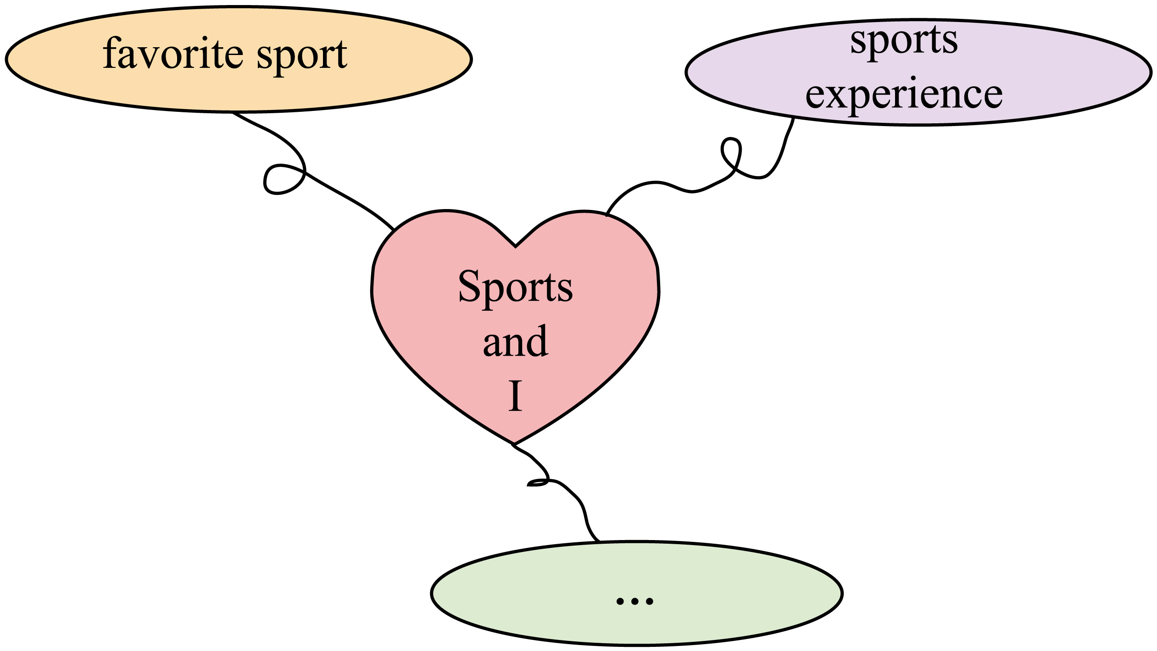
注意：
1. 可在原有思维导图内容提示的基础上适当拓展信息；
2. 词数80词左右，开头和结尾已给出，不算入词数；
3. 不得透露学校、姓名等任何个人信息，否则不予评分。
Sports and I
My dear teacher and classmates,
Today, I’m very happy to have the chance to talk about a topic that is very important to me: Sports and I. ____________________________________________________________________________________________________________________________________________________________________________________________________________________________________________________________________________________________________
That’s all. Thank you!
【答案】例文
Sports and I
My dear teacher and classmates,
Today, I’m very happy to have the chance to talk about a topic that is very important to me: Sports and I. I love sports because they keep me healthy and happy. My favorite sport is basketball, as it helps build my teamwork skills. I enjoy playing with friends after class. Once, we took part in a friendly match, which taught me the importance of cooperation and perseverance. Sports not only make me stronger physically, but also more confident in facing challenges. I hope everyone can find their own favorite sport and truly enjoy it. That way, we can stay energetic together.
That’s all. Thank you!
【解析】
【详解】[总体分析]
①题材：本文是一篇演讲稿；
②时态：本文应使用“一般现在时”为主；
③提示：应注意题干给出的要点并适当补充，使文章内容充实。
[写作步骤]
第一步，借用文章已给开头，引出主题；
第二步，根据题干思维导图的要点，介绍自己喜欢的运动和自己的运动经历；
第三步，点评运动带给自己的积极影响，并收尾。
[亮点词汇]
①take part in参加
②not only…but also不仅……而且
[高分句型]
①I love sports because they keep me healthy and happy. （原因状语从句）
②Once, we took part in a friendly match, which taught me the importance of cooperation and perseverance.（定语从句）

