**2025年广东省初中学业水平考试**

**英语**

**（考试时间：90分钟 试卷满分：90分）**

**注意事项：**

**1.答卷前，考生务必用黑色字迹的钢笔或签字笔将自己的班级、姓名和座位号填写在答题卡上。用2B铅笔在“准考证号”栏相应位置填涂自己的准考证号。**

**2.作答选择题时，选出每小题答案后，用2B铅笔把答题卡上对应题目选项的答案信息点涂黑；如需改动，用橡皮擦干净后，再选涂其他答案，答案不能答在试卷上。**

**3.非选择题必须用黑色字迹的钢笔或签字笔作答，答案必须写在答题卡各题目指定区域内相应位置上；如需改动，先划掉原来的答案，然后再写上新的答案；不准使用铅笔和涂改液。不按以上要求作答的答案无效。**

**4.考生必须保持答题卡的整洁。考试结束后，将试卷和答题卡一并交回。**

**一、听说应用（本大题共30小题，每小题1分，共30分；A、B、C、D部分为听力理解，E部分为情景对话）**

**A.听句子（本题共5小题，每小题1分，共5分）**

**请根据所听内容，选择符合题意的图画回答问题，并在答题卡上将对应选项涂黑。每个句子听两遍。**

1. When was the school sports day?【此处可播放相关音频，请去附件查看】

A. 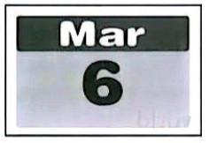 B. 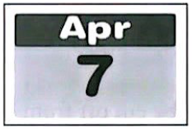 C. 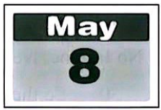

2. Which sport did Li Lei take part in?【此处可播放相关音频，请去附件查看】

A. 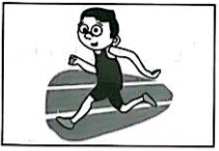 B. 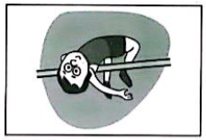 C. 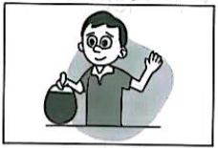

3. Who cheered him on at the competition?【此处可播放相关音频，请去附件查看】

A. 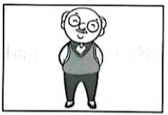 B. 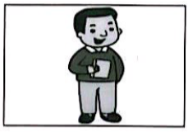 C. 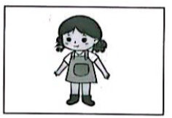

4. What prize did Li Lei get?【此处可播放相关音频，请去附件查看】

A. 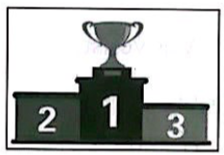 B. 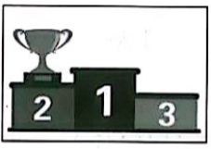 C. 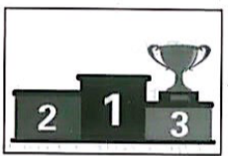

5. Where did Li Lei go the next day?【此处可播放相关音频，请去附件查看】

A. 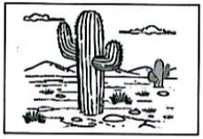 B. 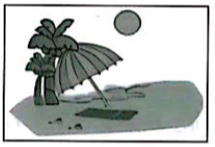 C. 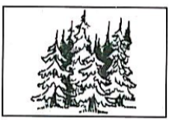

**B.听对话（本题共10小题，每小题1分，共10分）**

**请根据每段对话的内容回答问题，从每小题所给的三个选项中选出一个最佳答案，并在答题卡上将对应选项涂黑。每段对话听两遍。**

6. How does Jenny feel?【此处可播放相关音频，请去附件查看】

A. Happy. B. Tired. C. Angry.

7. Which car does the woman prefer?【此处可播放相关音频，请去附件查看】

A. The red one. B. The blue one. C. The black one.

8. How often does John go fishing?【此处可播放相关音频，请去附件查看】

A. Once a week. B. Twice a week. C. Every day.

9. Why do they have to stop working?【此处可播放相关音频，请去附件查看】

A. For safety. B. For a break. C. For some training.

10. What was the news about?【此处可播放相关音频，请去附件查看】

A. Action movies. B. A live interview. C. Space exploration.

听对话，回答问题。【此处可播放相关音频，请去附件查看】

11. How is Danny arriving there?

A. By bus. B. By taxi. C. By underground.

12. What are they going to do?

A. To have a meal. B. To buy a table. C. To see a dentist.

听对话，回答问题。【此处可播放相关音频，请去附件查看】

13. Who are they talking about?

A. A poet. B. A thinker. C. A novelist.

14. What is the name of the book?

A. *The Little Prince* B. *Leaves of Grass* C. *The Art of War*

15. How will Kate get a copy of the book?

A. She will buy one. B. She will borrow one. C. She will download one.

**C.听短文（本题共5小题，每小题1分，共5分)**

请根据所听内容，从每小题所给的三个选项中选出一个最佳答案，并在答题卡上将对应选项涂黑。短文听两遍。【此处可播放相关音频，请去附件查看】

16. How was the weather last Sunday?

A. Sunny. B. Windy. C. Cloudy.

17. Where did Dad put the balloons?

A. On the wall. B. On the grass. C. On the trees.

18. What did Grandpa use to be?

A. A baseball manager. B. A football player. C. A basketball coach.

19. Who got out of the car?

A. Grandpa’s fans. B. Grandpa’s friends. C. Grandpa’s relatives.

20. What is the passage mainly about?

A. A party. B. A match. C. A show.

**D.听填信息（本题共5小题，每小题1分，共5分)**

你将听到关于学校音乐会筹备工作的会议内容。请根据所听内容填写下面的信息卡，并将答案写在答题卡对应题目的答题位置上。短文听两遍。【此处可播放相关音频，请去附件查看】

|  |
| --- |
| 学科网(www.zxxk.com)--教育资源门户，提供试卷、教案、课件、论文、素材以及各类教学资源下载，还有大量而丰富的教学相关资讯！ L3I5B6j3nsTNAx1ODbqMbQ==  Meeting About the School Concert  Subject: preparations for next Thursday’s concert “Sound of ____21____”  Tasks:  Group 1: to take care of the ____22____  Group 2: to make the music hall clean and ____23____  Group 3: to ____24____ the musical instruments  Group 4: to receive the ____25____ honored guests on the list |

**E.情景对话（本题共5小题，每小题1分，共5分)**

请通读下面对话，根据对话内容，从选项中选出能填入空白处的最佳选项，并在答题卡上将对应选项涂黑。选项中有一项为多余选项。

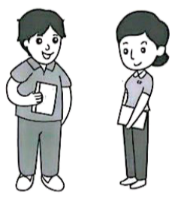

Ann: Hello, Ted. How did you feel about the dinner last night?

Ted: ____26____ The food was good, but there wasn’t much communication among us.

Ann: Yeah. Everyone fixed their eyes on the screen. ____27____

Ted: Me too. People were closer back then.

Ann: Exactly. ____28____

Ted: Well, how about organizing a camp?

Ann: Good idea. Maybe we can make it into a “NINP” camp.

Ted: NINP? ____29____

Ann: No Internet No Phones.

Ted: ____30____ So the camp must be cut off from the outside world.

Ann: Right. Then we can have a great time chatting and playing outdoor games.

A. Oh, I see.

B. I didn’t quite enjoy it.

C. What does that mean?

D. Were you using the phone?

E. Let’s do something different next time.

F. I miss the days without mobile phones.

**二、语法选择（本大题共10小题，每小题1分，共10分）**

请通读下面短文，掌握其大意，根据语法和上下文连贯的要求，从每小题所给的三个选项中选出一个最佳答案，并在答题卡上将对应选项涂黑。

Lily works as a main cook in a famous restaurant. It was her mom who guided her into the world of cooking.

When she was a little girl, Lily spent a lot of time with mom in the kitchen.

She remembered that she would always sit there ___31___ watch mom cooking. She was curious about ___32___ mom was busy with. When she was older, she ___33___ to do easy tasks like beating eggs. Later on, while mom was making dumplings, Lily would help cut vegetables ___34___ a small knife. She also learned how to make dumplings of ___35___ shapes. To a girl of her age, cooking was real magic. As Lily grew up, she learned more about food and tried cooking ___36___ dishes than before. After finishing college, she decided ___37___ in a restaurant. With wild imagination, she came up with many new ideas and started to create ___38___ own dishes. So far, she ___39___ many dishes with special tastes. All these dishes are popular with customers.

Today, the kitchen is still a place for Lily and mom to have ____40____ fun together. Every time before a family dinner party, they will cooperate to plan a menu. Cooking has kept their mother-daughter relationship strong.

31. A. or B. and C. but

32. A. what B. that C. whether

33. A. is allowed B. was allowed C. was allowing

34. A. by B. for C. with

35 A. different B. difference C. differently

36. A. difficult B. more difficult C. the most difficult

37. A. work B. working C. to work

38. A. her B. hers C. herself

39. A. invents B. will invent C. has invented

40. A. / B. a C. the

**三、完形填空（本大题共10小题，每小题1分，共10分）**

请通读下面短文，掌握其大意，从每小题所给的四个选项中选出一个最佳答案，并在答题卡上将对应选项涂黑。

In a narrow hutong in Beijing lies a small library. It is only seven square meters in size, but thousands of books are ___41___ in it. Unlike traditional libraries, this one doesn’t require its readers to ___42___ the books. Instead, it encourages them to pass those books on to someone else when they’ve finished reading.

This library was ___43___ by Mr. Xu, a businessman, in 2010. The idea took shape when Xu recommended books online to students, but found it ___44___ for them to get the books from their school libraries. So, Xu bought and ___45___ nearly 1,000 books in the following year. The students who received the books were very thankful. Their thank-you letters got Xu to turn his book-gifting effort into a physical space.

Xu’s library might be the smallest in the world, but in another sense, it’s also the biggest because its books keep ___46___. Once, a reader took home an English book on Chinese history. A week later, he passed it on to a neighbor. ___47___, the book traveled all the way abroad and ended up in Germany. “The ___48___ of the book is a wonder. Many wonders like this keep the culture of reading alive,” Xu tells the newspaper.

Xu says he will continue this work although the library is now faced with the ___49___ of e-books. “This is the most ____50____ thing I’ve done in my life,” he says. “I hope that the library can stay open forever.”

41. A. kept B. written C. printed D. punished

42. A. return B. copy C. lend D. buy

43. A. locked B. started C. hidden D. guarded

44. A. hard B. harmful C. possible D. interesting

45. A. dug up B. picked up C. gave away D. threw away

46 A. burning B. moving C. falling D. shaking

47. A. Clearly B. Hopefully C. Generally D. Amazingly

48. A. history B. language C. journey D. background

49. A. death B. truth C. mistake D. challenge

50. A. silly B. scary C. common D. meaningful

**四、阅读理解（本大题共15小题，每小题2分，共30分）**

**请阅读A、B两篇短文，从每小题所给的四个选项中选出能回答所提问题或完成所给句子的最佳答案，并在答题卡上将对应选项涂黑。**

**A**

|  |  |  |
| --- | --- | --- |
| 学科网(www.zxxk.com)--教育资源门户，提供试卷、教案、课件、论文、素材以及各类教学资源下载，还有大量而丰富的教学相关资讯！ L3I5B6j3nsTNAx1ODbqMbQ== | **Are mosquitoes driving you crazy?**  **This summer, make some mint oil to drive them away!**  Mosquitoes are awful. They seem to be everywhere and may bite you badly. This makes mint (薄荷) oil a perfect gift for your family and friends in summer. This weekend, you can try making mint oil FOR FREE. | |
| **Time**: 9:00 a.m.— 11:50 a.m. Saturday (July 5)  **Place**: Riverside Community Center  **Please note**:  ♥ We’ll get all the tools and materials ready.  ♥ For 40 people only. First come, first served.  ♥ To book a place for the activity, please call Lucy at 345878 by 7:00 p.m. Friday.  ---------------------------------------------------------------------------------------------------------------------- | | |
| For those who would like to practice it at home, here are the steps:  ◆ Cut up the mint. Put it into a bottle with olive (橄榄) oil.  ◆ Cover the bottle and place it in hot water. | | 学科网(www.zxxk.com)--教育资源门户，提供试卷、教案、课件、论文、素材以及各类教学资源下载，还有大量而丰富的教学相关资讯！ L3I5B6j3nsTNAx1ODbqMbQ== |
| ◆ When the water cools down, move the bottle to a warm area and leave it there for at least two hours.  ◆ Pour the mixture onto a thin piece of cotton cloth on top of a dark bottle. Let the oil go through the cloth into the bottle. Now you get your homemade mint oil. | | |

51. When will this community event take place?

A. This Friday afternoon. B. Next Friday afternoon.

C. This Saturday morning. D. Next Saturday morning.

52. How many people can take part in the activity?

A. At least forty. B. At least fifty. C. At most forty. D. At most fifty.

53. Why would people call Lucy before the event?

A. To win a gift. B. To book a place.

C. To get mint oil. D. To buy some tools.

54. What is the right order of the steps?

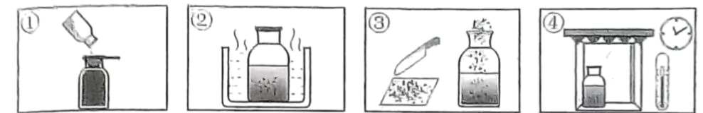

A. ③→①→②→④ B. ②→④→①→③ C. ②→①→③→④ D. ③→②→④→①

55. What is the main purpose of the passage?

A. To introduce an activity. B. To survey the users of a product.

C. To recommend a product. D. To report the success of an activity.

**B**

Everyone knows that forests help fight climate change. However, a recent scientific report shows that the world lost 300,000 square kilometers of forests in 2024. That’s an area about the size of Italy.

According to the report, for the first time ever, fires were the biggest cause of forest loss. ▲ . This country has the largest area of rainforest in the world. Last year, it suffered from a long period of dry weather. Wildfires broke out and spread. As a result, about 25,000 square kilometers of the primary rainforest disappeared in the country. This meant fires caused 66% of its forest loss.

The second biggest cause of the world’s forest loss was clearing land for farming. As people need more farmland, they keep cutting down forests every year. In 2024, the area of forest cleared for farming increased by 14% worldwide. The situation was more **severe** in developing countries. For example, Bolivia’s forest loss doubled in 2024.

Without doubt, something must be done. Experts call on governments, businesses and people to work together before it is too late. It seems that China has set a good example. Thanks to cooperation at many levels, China had the biggest increase in forest area among all countries in 2024. That year alone, newly-planted trees in China covered an area of nearly 45,000 square kilometers, according to a news report. If more countries start to take action like China, the earth will become a greener planet.

56. The size of Italy is mentioned in Paragraph 1 to show _______.

A. why we need forests. B. where a disaster spread.

C. what climate change is. D. how terrible forest loss was.

57. Which of the following can be put in “ ▲ ” in Paragraph 2?

A. Farming is a reason. B. Take Brazil for example.

C. Wildfires were stopped. D. Read the report carefully.

58. What does the underlined word “**severe**” in Paragraph 3 mean?

A. Serious. B. Boring. C. Balanced. D. Positive.

59. What was the reason for the growth of China’s forest area in 2024?

A. Enough land. B. Nice weather. C. Good teamwork. D. Green technology.

60. What is the best title for the passage?

A. Rainforest Became Larger B. Farmland Area Grew Rapidly

C. Forest Fires Caused Pollution D. Forest Loss Worried the World

**C**

配对阅读。左栏是五则向AI提问的指引，右栏是7个具体的例子。请为每则指引匹配对应的例子，并在答题卡上将对应选项涂黑。选项中有两项为多余项。

|  |  |
| --- | --- |
| ____61____ Don’t use general questions when you ask AI for instructions. Instead, ask it to give you clear steps.  ____62____ Make no mistakes in your questions, or you may not get correct answers.  ____63____ AI can answer questions about facts. But don’t try to ask it for other people’s private information.  ____64____ If you are not happy with a painting or a song AI creates, give it more instructions until you get what you like.  ____65____ It’s better to tell AI who you are. In this way, you’ll get answers that meet your needs. | A. If you are wondering about the population of Canada, questions like “*What is the popular of Canada*?” will not get you the correct answer.  B. Instead of asking “*How do I cook a meal*?” you can say “*What are the steps to make a pancake with a pan*?”  C. If you tell AI “*Guess if I’m happy today*,” it will fail to do it because it has no ability to judge human feelings.  D. If you aren’t satisfied with the picture AI draws, give more requirements like “*Please add a pink window and paint the walls yellow*.”  E. For a student who wants to improve his English reading, it is better to ask questions like “*How can I improve my English reading as a Grade 9 student*?”  F. If you ask “*Could you tell me the address of my desk-mate Mary*?” AI will refuse to give you the answer because it is designed to protect people’s personal information.  G. A question like “*Will it be nice tomorrow for jogging outside*?” should be changed into “*What is the weather like tomorrow*?” |

**五、短文填空（共10小题，每小题1.5分，满分15分）**

请从方框内选择适当的词并用其正确形式填空，使文章完整连贯。注意每空一词，每词仅用一次，有两词为多余项。

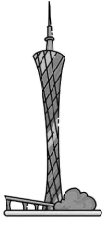

|  |
| --- |
| along although beauty because deep enjoy example explore new performance something under |

Mike is a landscape architect (设计师) from Europe. He came to Guangzhou 16 years ago and has never left since then.

Mike says he likes Guangzhou very much ____66____ the city is full of life. He lives in a traditional neighborhood. Every day, he can see his neighbors playing chess in the park, dancing ____67____ the river or chatting in the market. Mike ____68____ seeing these moments. He thinks the ____69____ of a city lies in both its people and its environment. “When people are connected to a place, it brings life to it,” Mike says.

Recently, Mike has formed a habit of cycling around to ____70____ the city at weekends. He says he loves to see old neighborhoods take on a ____71____ look. For him, city development is not about building ____72____ new, but about making use of what’s already there in a creative way. His favorite ____73____ is a car repair shop near his home. As people get together there at night and give some ____74____ of Guangdong opera, the shop turns into a community theater. “It wasn’t designed to be one; it just became one,” Mike tells a reporter. “This influenced me _____75_____. I came to realize that, as architects, we should design with people to keep a city alive.”

**六、读写综合（本大题分为A、B两部分，共25分）**

A. 回答问题

请阅读下面短文，根据所提供的信息，回答五个问题，并将答案写在答题卡对应题目的答题位置上。要求所写答案语法正确、信息完整切题。

|  |  |
| --- | --- |
| **Youth Weekly June 21. 2025** | |
| 学科网(www.zxxk.com)--教育资源门户，提供试卷、教案、课件、论文、素材以及各类教学资源下载，还有大量而丰富的教学相关资讯！ L3I5B6j3nsTNAx1ODbqMbQ== ***The Big Debate*** | |
| **Is it better to visit a museum virtually or in person?** | |
| Now, many museums offer virtual (虚拟的) The Pie Chart of the Voting Result tours online to their visitors. Last week, we invited our readers to vote on whether they like to visit a museum virtually or in person. We received 3,386 votes in total. The result is shown by the pie chart (饼图) on the right. | 学科网(www.zxxk.com)--教育资源门户，提供试卷、教案、课件、论文、素材以及各类教学资源下载，还有大量而丰富的教学相关资讯！ L3I5B6j3nsTNAx1ODbqMbQ== |
| Here are some opinions from the readers:  The experience will be so different when you are there and see things close up by yourself. It is something that virtual visits can’t provide.  *—Elvis007*  Virtual tours of a museum offer convenience to people like me. I am always busy with work I don’t have time to travel many miles to visit a museum.  —*Tony08*  Last year, the famous Mogao Cave 285 was closed to the public for some repairs. I had to pay a virtual visit to the cave. Thanks to the new technology, I bad a fantastic experience. It seemed that the dancers in the wall painting were dancing right in front of me.  —*Lulu2025*  I think nothing can compare to visiting a physical museum. I’ve been to some museums that provide hands-on activities. Once, I touched a rope from an ancient warship. At that moment, I felt like a time traveler to the past.  —*Heidi36* | |

76. How many readers would like to visit a museum virtually according to the pie chart?

_________________________________________

77. Does *Elvis007* prefer to visit a museum in person or virtually?

_________________________________________

78. What does *Tony08* think of virtual tours of a museum?

_________________________________________

79. Why did *Lulu2025* have to visit Mogao Cave 285 virtually last year?

_________________________________________

80. What did *Heidi36* feel like when she touched the rope?

_________________________________________

B 书面表达

81. 请根据要求完成短文写作，并将短文写在答题卡对应题目的答题位置上。

假设你是李明。你校计划与市博物馆合作举办民俗体验活动，需要同学们从若干民俗项目中选出最想体验的一项。你期待交换生Peter也参与投票。请你根据以下思维导图的提示，写一封电子邮件给他。

|  |  |  |
| --- | --- | --- |
| 给Peter的邮件 | | |
| 目前票数最高的两项  1.舞狮  2.…… | 你的选择  1.项目名称  2.选择理由（2点）  3.项目目前得票情况 | 你的期待  …… |

注意：

（1）可在思维导图内容提示的基础上适当拓展信息。

（2）不能照抄原文；不得在作文中出现真实校名和考生的真实姓名。

（3）语句连贯，词数80左右。作文开头和结尾已经给出，不计入总词数，也不必抄写在答题卡上。

Dear Peter,

Our school and the city museum will hold an event for us to get a taste of a folk custom. We are invited to vote for our favorite, and lion dance comes first now.

_________________________________________________________________________________________________________________________________________________________________________________________________________________________________________________________________________________________________________________________________________

Best,

Li Ming

**2025年广东省初中学业水平考试**

**英语**

**（考试时间：90分钟 试卷满分：90分）**

**注意事项：**

**1.答卷前，考生务必用黑色字迹的钢笔或签字笔将自己的班级、姓名和座位号填写在答题卡上。用2B铅笔在“准考证号”栏相应位置填涂自己的准考证号。**

**2.作答选择题时，选出每小题答案后，用2B铅笔把答题卡上对应题目选项的答案信息点涂黑；如需改动，用橡皮擦干净后，再选涂其他答案，答案不能答在试卷上。**

**3.非选择题必须用黑色字迹的钢笔或签字笔作答，答案必须写在答题卡各题目指定区域内相应位置上；如需改动，先划掉原来的答案，然后再写上新的答案；不准使用铅笔和涂改液。不按以上要求作答的答案无效。**

**4.考生必须保持答题卡的整洁。考试结束后，将试卷和答题卡一并交回。**

**一、听说应用（本大题共30小题，每小题1分，共30分；A、B、C、D部分为听力理解，E部分为情景对话）**

**A.听句子（本题共5小题，每小题1分，共5分）**

**请根据所听内容，选择符合题意的图画回答问题，并在答题卡上将对应选项涂黑。每个句子听两遍。**

【1题答案】

【答案】C

【2题答案】

【答案】B

【3题答案】

【答案】C

【4题答案】

【答案】A

【5题答案】

【答案】B

**B.听对话（本题共10小题，每小题1分，共10分）**

**请根据每段对话的内容回答问题，从每小题所给的三个选项中选出一个最佳答案，并在答题卡上将对应选项涂黑。每段对话听两遍。**

【6题答案】

【答案】A

【7题答案】

【答案】C

【8题答案】

【答案】A

【9题答案】

【答案】A

【10题答案】

【答案】C

【11~12题答案】

【答案】11. B 12. A

【13~15题答案】

【答案】13. B 14. C 15. B

**C.听短文（本题共5小题，每小题1分，共5分)**

【16~20题答案】

【答案】16 A 17. C 18. B 19. B 20. A

**D.听填信息（本题共5小题，每小题1分，共5分)**

【21~25题答案】

【答案】21. Spring

22. singers

23. tidy 24. carry

25. 20##twenty

**E.情景对话（本题共5小题，每小题1分，共5分)**

【26~30题答案】

【答案】26. B 27. F 28. E 29. C 30. A

**二、语法选择（本大题共10小题，每小题1分，共10分）**

【31~40题答案】

【答案】31. B 32. A 33. B 34. C 35. A 36. B 37. C 38. A 39. C 40. A

**三、完形填空（本大题共10小题，每小题1分，共10分）**

【41~50题答案】

【答案】41. A 42. A 43. B 44. A 45. C 46. B 47. D 48. C 49. D 50. D

**四、阅读理解（本大题共15小题，每小题2分，共30分）**

**请阅读A、B两篇短文，从每小题所给的四个选项中选出能回答所提问题或完成所给句子的最佳答案，并在答题卡上将对应选项涂黑。**

**A**

【51~55题答案】

【答案】51. C 52. C 53. B 54. D 55. A

**B**

【56~60题答案】

【答案】56. D 57. B 58. A 59. C 60. D

**C**

【61~65题答案】

【答案】61. B 62. A

63. F 64. D

65. E

**五、短文填空（共10小题，每小题1.5分，满分15分）**

【66~75题答案】

【答案】66 because

67. along 68. enjoys

69. beauty 70. explore

71. new 72. something

73. example

74. performances

75. deeply

**六、读写综合（本大题分为A、B两部分，共25分）**

【76~81题答案】

【答案】76. 1557.

77. In person.

78. They offer convenience to people.

79. Because Mogao Cave 285 was closed to the public for some repairs last year.

80. She felt like a time traveler to the past.

81. 例文：

Dear Peter,

Our school and the city museum will hold an event for us to get a taste of a folk custom. We are invited to vote for our favorite, and lion dance comes first now.

I’ve chosen Chinese knot-tying. Firstly, it’s a very delicate and creative craft. You can use different colors and lengths of ropes to make various shapes like butterflies or flowers, which can be used as decorations at home. Secondly, it has rich cultural meanings. Chinese knots often symbolize good luck and unity in Chinese culture. I believe it has great potential.

I really hope you can take part in this voting. Your vote might make a difference. Looking forward to your choice.

Best,

Li Ming